

FRA Milestone-1 and 2 Business Report

DEEPTI AGRAWAL

Submission Date:

24th October 2021

CONTENTS

Credit Risk Dataset:

Problem Statement…………………………………………………………………………………………….3

Data Dictionary………………………………………………………………………………………………..3

Outlier Treatment…………………………………………………………………………………………......9

Missing Values…………………………………………………………………………………………..........10

Defining Target Variable……………………………………………………………………………………..11

Univariate and Bivariate Analysis……………………………………………………....................................11

Train Test Split………………………………………………………………………………………….........17

Logistic Regression Model…………………………………………………………………………………...17

Model Validation & Performance Matrices…………………………………………………………………..21

Random Forest Model…………………………………………………………………………………..........27

LDA Model…………………………………………………………………………………..........................29

Performance Metrics…………………………………………………………………………………...........30

Stock Price Graph…………………………………………………………………………………...............33

Returns for all stocks…………………………………………………………………………………...........35

Stock Mean & Standard Deviation…………………………………………………………………………..37

THE END! .........................................................................................................................................................38

Problem Statement:
Businesses or companies can fall prey to default if they are not able to keep up their debt obligations. Defaults will lead to a lower credit rating for the company which in turn reduces its chances of getting credit in the future and may have to pay higher interests on existing debts as well as any new obligations. From an investor's point of view, he would want to invest in a company if it is capable of handling its financial obligations, can grow quickly, and is able to manage the growth scale.
A balance sheet is a financial statement of a company that provides a snapshot of what a company owns, owes, and the amount invested by the shareholders. Thus, it is an important tool that helps evaluate the performance of a business.
Data that is available includes information from the financial statement of the companies for the previous year (2015). Also, information about the Networth of the company in the following year (2016) is provided which can be used to drive the labeled field.

Data Dictionary:

S No. | Column Name | Description
1 | Co_Code | Company Code
2 | Co_Name | Company Name
3 | Networth Next Year | Value of a company as on 2016 - Next Year(difference between the value of total assets and total liabilities)
4 | Equity Paid Up | Amount that has been received by the company through the issue of shares to the shareholders
5 | Networth | Value of a company as on 2015 - Current Year
6 | Capital Employed | Total amount of capital used for the acquisition of profits by a company
7 | Total Debt | The sum of money borrowed by the company and is due to be paid
8 | Gross Block | Total value of all of the assets that a company owns
9 | Net Working Capital | The difference between a company's current assets (cash, accounts receivable, inventories of raw materials and finished goods) and its current liabilities (accounts payable).
10 | Current Assets | All the assets of a company that are expected to be sold or used as a result of standard business operations over the next year.
11 | Current Liabilities and Provisions | Short-term financial obligations that are due within one year (includes amount that is set aside cover a future liability)
12 | Total Assets/Liabilities | Ratio of total assets to liabilities of the company
13 | Gross Sales | The grand total of sale transactions within the accounting period
14 | Net Sales | Gross sales minus returns, allowances, and discounts
15 | Other Income | 15 Income realized from non-business activities (e.g. sale of long term asset)
16 | Value Of Output | Product of physical output of goods and services produced by company and its market price
17 | Cost of Production | Costs incurred by a business from manufacturing a product or providing a service
18 | Selling Cost | Costs which are made to create the demand for the product (advertising expenditures, packaging and styling, salaries, commissions and travelling expenses of sales personnel, and the cost of shops and showrooms)
19 | PBIDT | Profit Before Interest, Depreciation & Taxes
20 | PBDT | Profit Before Depreciation and Tax
21 | PBIT | Profit before interest and taxes
22 | PBT | Profit before tax
23 | PAT | Profit After Tax
24 | Adjusted PAT | Adjusted profit is the best estimate of the true profit
25 | CP | Commercial paper, a short-term debt instrument to meet short-term liabilities.
26 | Revenue earnings in forex | Revenue earned in foreign currency
27 | Revenue expenses in forex | Expenses due to foreign currency transactions
28 | Capital expenses in forex | Long term investment in forex
29 | Book Value (Unit Curr) | Net asset value
30 | Book Value (Adj.) (Unit Curr) | Book value adjusted to reflect asset's true fair market value
31 | Market Capitalisation | Product of the total number of a company's outstanding shares and the current market price of one share
32 | CEPS (annualised) (Unit Curr) | Cash Earnings per Share, profitability ratio that measures the financial performance of a company by calculating cash flows on a per share basis
33 | Cash Flow From Operating Activities | Use of cash from ongoing regular business activities
34 | Cash Flow From Investing Activities | Cash used in the purchase of non-current assets–or long-term assets– that will deliver value in the future
35 | Cash Flow From Financing Activities | Net flows of cash that are used to fund the company (transactions involving debt, equity, and dividends)
36 | ROG-Net Worth (%) | Rate of Growth - Networth
37 | ROG-Capital Employed (%) | Rate of Growth - Capital Employed
38 | ROG-Gross Block (%) | Rate of Growth - Gross Block
39 | ROG-Gross Sales (%) | Rate of Growth - Gross Sales
40 | ROG-Net Sales (%) | Rate of Growth - Net Sales
41 | ROG-Cost of Production (%) | Rate of Growth - Cost of Production
42 | ROG-Total Assets (%) | Rate of Growth - Total Assets
43 | ROG-PBIDT (%) | Rate of Growth- PBIDT
44 | ROG-PBDT (%) | Rate of Growth- PBDT
45 | ROG-PBIT (%) | Rate of Growth- PBIT
46 | ROG-PBT (%) | Rate of Growth- PBT
47 | ROG-PAT (%) | Rate of Growth- PAT
48 | ROG-CP (%) | Rate of Growth- CP
49 | ROG-Revenue earnings in forex (%) | Rate of Growth - Revenue earnings in forex
50 | ROG-Revenue expenses in forex (%) | Rate of Growth - Revenue expenses in forex
51 | ROG-Market Capitalisation (%) | Rate of Growth - Market Capitalisation
52 | Current Ratio[Latest] | Liquidity ratio, company's ability to pay short-term obligations or those due within one year
53 | Fixed Assets Ratio[Latest] | Solvency ratio, the capacity of a company to discharge its obligations towards long-term lenders indicating
54 | Inventory Ratio[Latest] | Activity ratio, specifies the number of times the stock or inventory has been replaced and sold by the company
55 | Debtors Ratio[Latest] | Measures how quickly cash debtors are paying back to the company
56 | Total Asset Turnover Ratio[Latest] | The value of a company's revenues relative to the value of its assets
57 | Interest Cover Ratio[Latest] | Determines how easily a company can pay interest on its outstanding debt
58 | PBIDTM (%)[Latest] | Profit before Interest Depreciation and Tax Margin
59 | PBITM (%)[Latest] | Profit Before Interest Tax Margin
60 | PBDTM (%)[Latest] | Profit Before Depreciation Tax Margin
61 | CPM (%)[Latest] | Cost per thousand (advertising cost)
62 | APATM (%)[Latest] | After tax profit margin
63 | Debtors Velocity (Days) | Average days required for receiving the payments
64 | Creditors Velocity (Days) | Average number of days company takes to pay suppliers
65 | Inventory Velocity (Days) | 66 Average number of days the company needs to turn its inventory into sales
66 | Value of Output/Total Assets | Ratio of Value of Output (market value) to Total Assets
67 | Value of Output/Gross Block | Ratio of Value of Output (market value) to Gross Block

Top 5 rows of Dataset
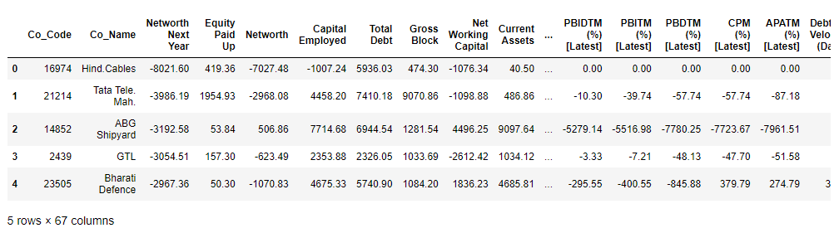

Shape of Dataset
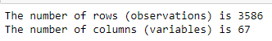
Info of Dataset
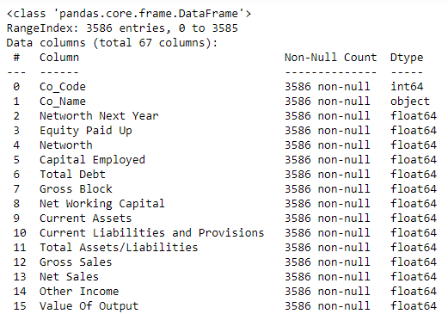
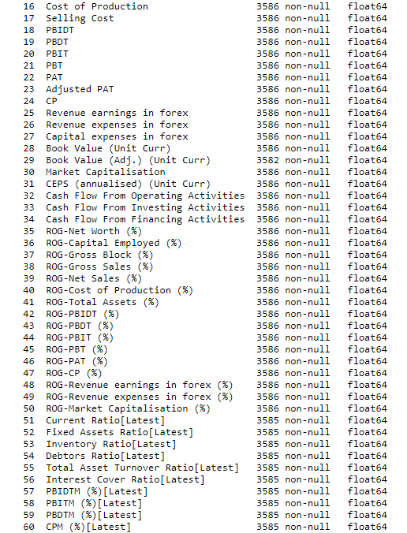
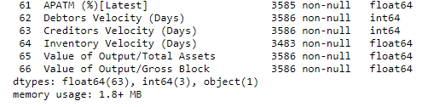
Descriptive Statistics
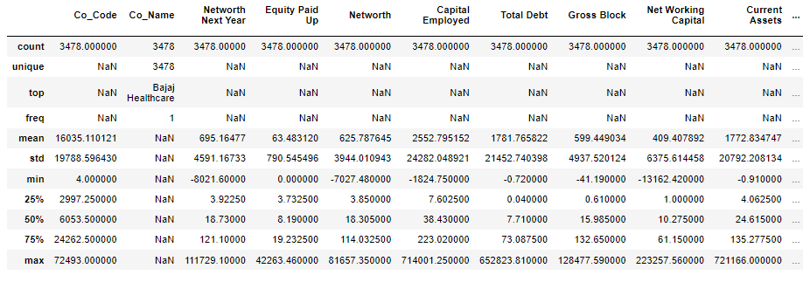
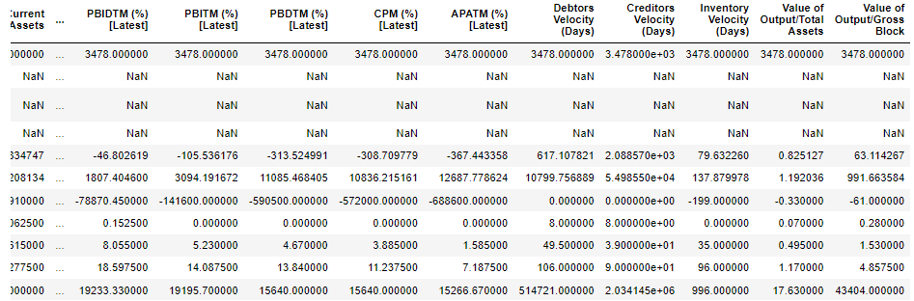
  - Outlier Treatment
Using boxplots we will check for outliers. Boxplots identify outliers based on the five point summary (min, 25%, 50%, 75%, max). Outliers are the values which fall outside the min-max range values.
We have removed the object variables as these cannot be evaluated using boxplots and also are insignificant to the model building part.
Outliers can be treated by different methods-
- Substituting with min max values
- Deleting the rows having outliers values
- Substituting with mean values
Below is the Boxplots for all the variables before treating the outliers
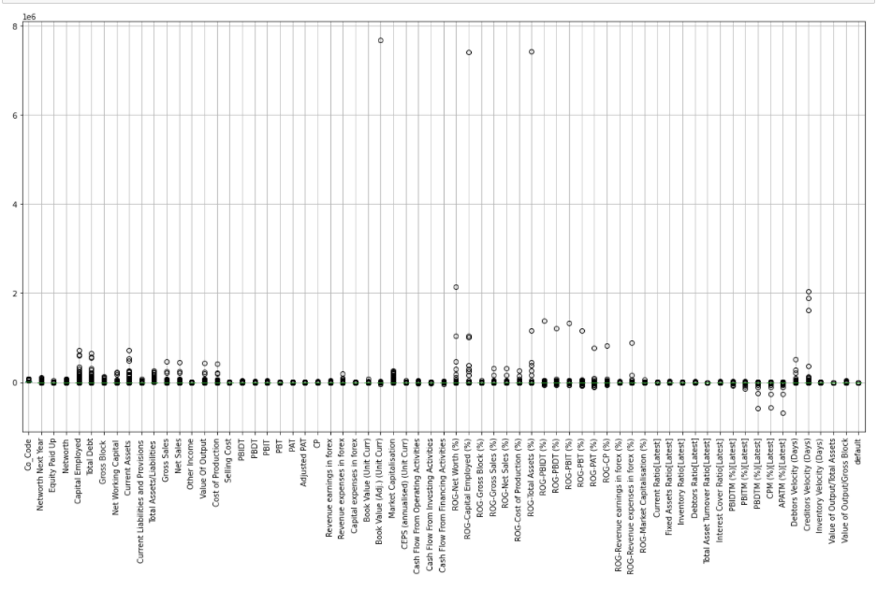
After treating the outliers using MIN-MAX Substitution-
In this model, values that are greater than the max values are substituted with the max value itself and the values which are less than the min value is replaced with the min value.
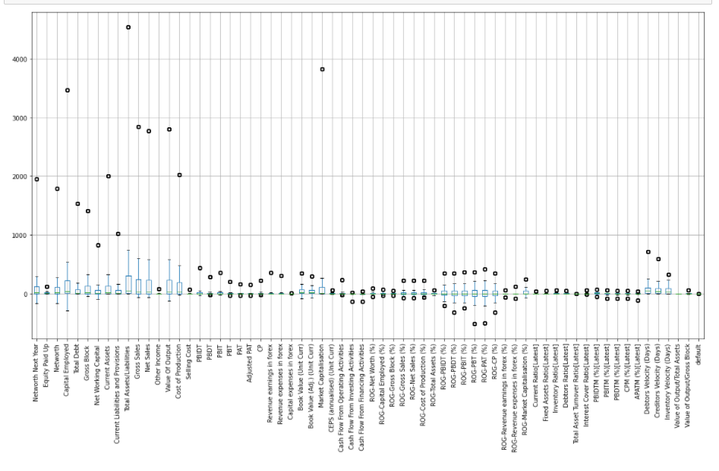
Now, we can see that there are some outliers still present in the data as these are now based on the new min max values and thus can be ignored.
  - Missing Value Treatment
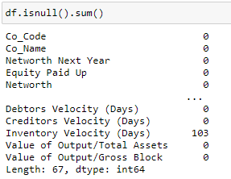
We can see that there are missing values present in our data.
We will go ahead with dropping them as these are insignificant to the total number of rows present in the dataset.
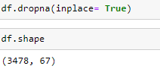
After dropping these values, we have come down to 3478 observations and 67 columns.
  - Transform Target variable into 0 and 1
Here target variable is defined as “default” variable. For this we need to first create a variable name “default” in the dataset. The value will be assigned based on the Net-worth Next Year. If the values is negative then 1 will be assigned and if values is positive 0 will be assigned.
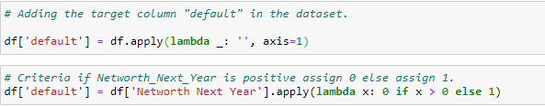
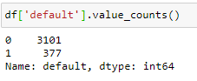
Checking Proportion of Default
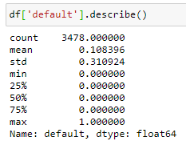
  - Univariate & Bivariate analysis
As, there are many variables present in the dataset, we will be checking analysis for some important variables only. The variables taken here for univariate analysis are based on the best VIF values.
- ROG-Gross Block (%) AND Current Ratio[Latest]
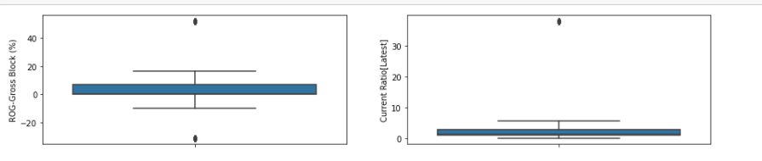
- Creditors Velocity (Days) AND Debtors Velocity (Days)
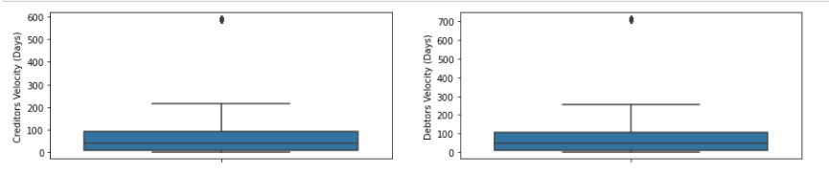
- Interest Cover Ratio[Latest] AND Debtors Ratio[Latest]
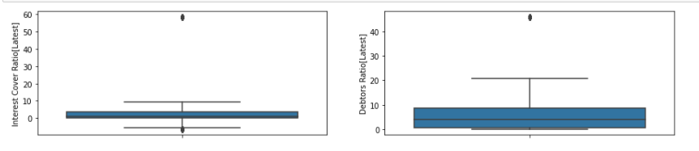
- ROG-Net Worth (%) AND Market Capitalisation
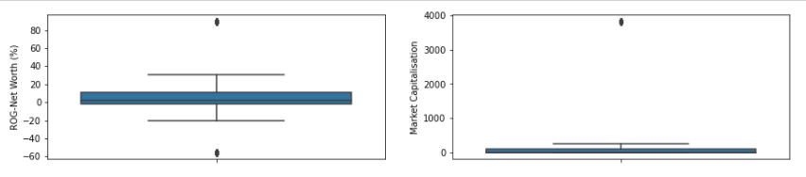
- CEPS (annualised) (Unit Curr) AND Total Debt
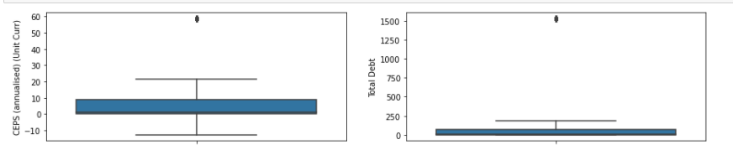

- Target Variable (default)
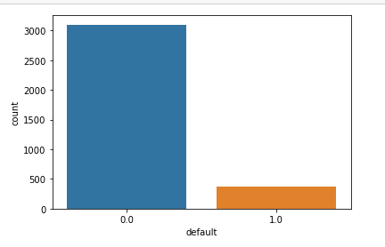
- HISTOGRAM PLOTS for all variables
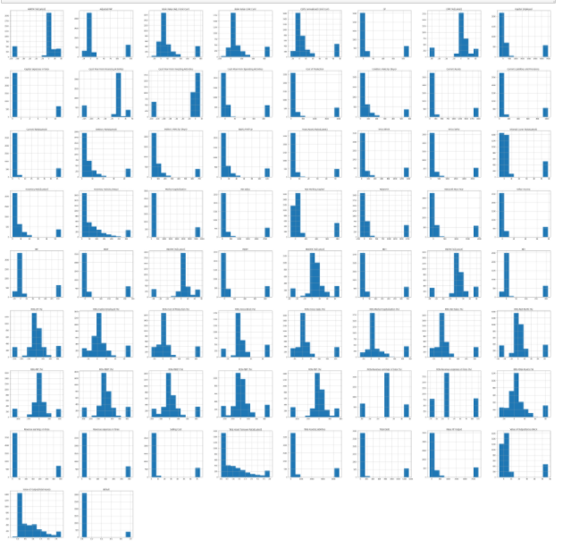
Bivariate and Multi variate Analysis-
- Default variable with CEPS (annualised) (Unit Curr) AND Value of Output/Gross Block
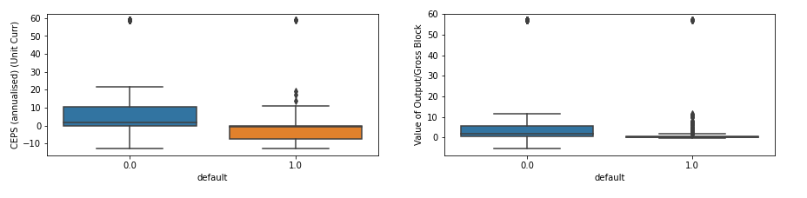
- Default variable with ROG-Net Worth (%) AND Market Capitalisation
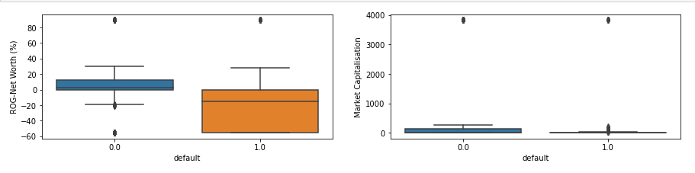
- Default variable with Interest Cover Ratio[Latest] AND Debtors Ratio[Latest]
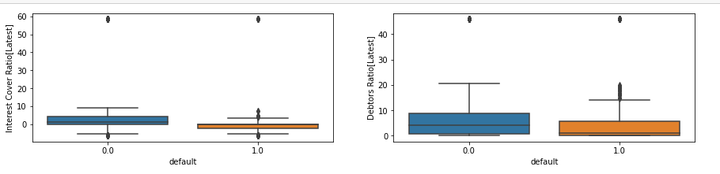
- Default variable with Creditors Velocity (Days) AND Debtors Velocity (Days)
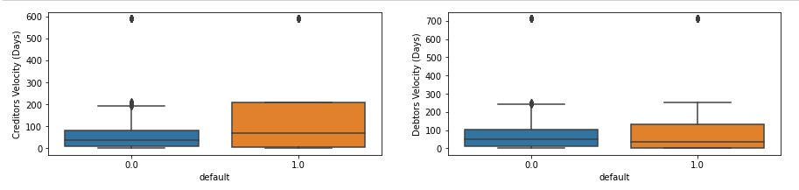
- Default variable with ROG-Gross Block (%) AND Current Ratio[Latest]
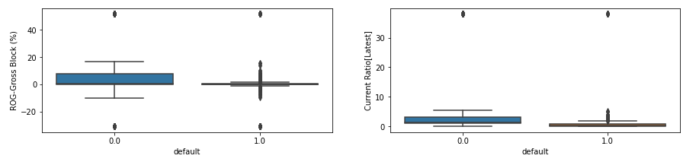
From the above we can observe what are the min and max values for different variables corresponding to the 0 and 1 value of the target variable.
Covariance Matrix
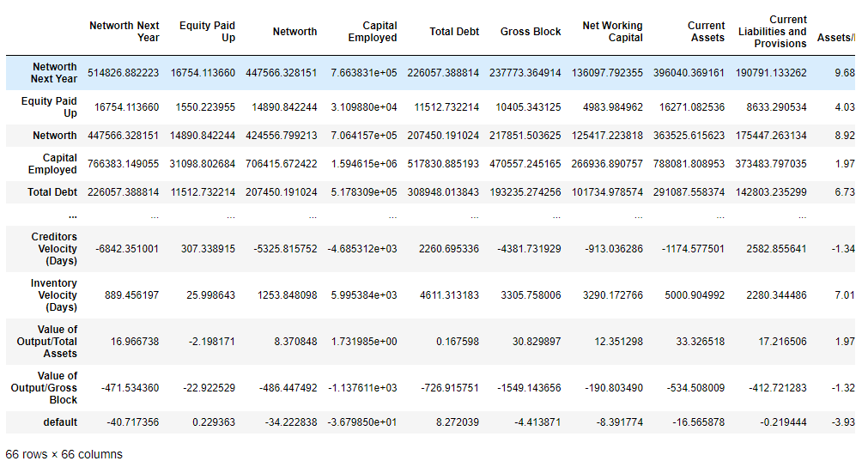
Correlation Matrix
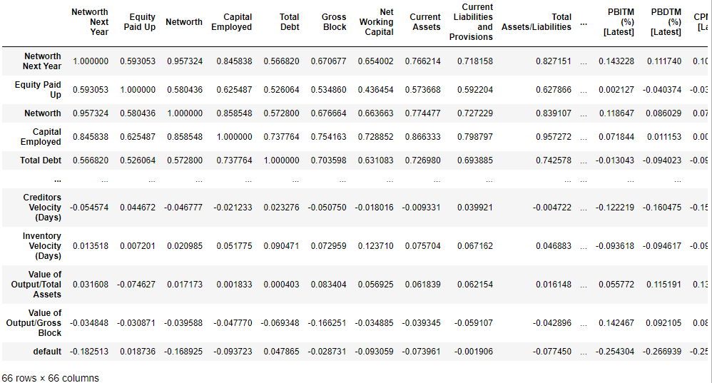
Heat Map
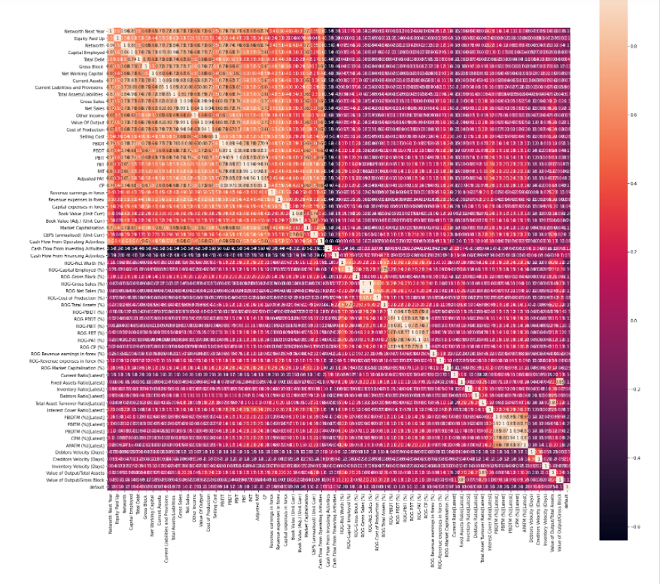

From the above graphs we can observe that 25% of the variables are highly interdependent on each other

  - Train Test Split
Before splitting the data, we will rename our columns for easy usage.
Renaming Column
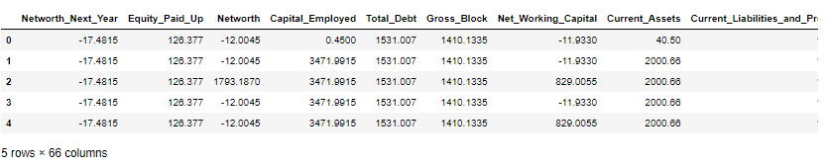
All the spaces has been replaced with ‘_’ and similarly other symbols also as required by problem and mentioned in the new field name of the data dictionary.
Splitting
Splitting arrays or matrices into random train and test subsets in ratio 67:33 and random_state=42. Model will be fitted on train set and predictions will be made on the test set.
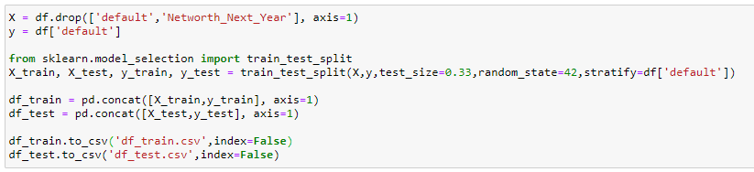
  - Build Logistic Regression Model (using statsmodel library) on most important variables on Train Dataset and choose the optimum cutoff. Also showcase your model building approach

Model Building using Logistic Regression for 'Probability at default'
The equation of the Logistic Regression by which we predict the corresponding probabilities and then go on predict a discrete target variable is
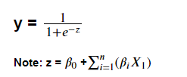
Creating logistic regression equation & storing it in f1
model = sm.logit(formula=’Dependent Variable ~ Σ𝐼𝑛𝑑𝑒𝑝𝑒𝑛𝑑𝑒𝑛𝑡 𝑉𝑎𝑟𝑖𝑎𝑏𝑙𝑒𝑠 (𝑘)’ data = ‘Data Frame containing the required values’).fit()
Model 1
Before building the model, let’s look at the problem of multi-collinearity. It occurs when two or more independent variables are highly correlated with one another in a regression model.
We can solve this problem by finding out the variables with best VIF (Variance inflation factor) values. We will on use the variables to build the model that have VIF values less than 5. As, VIF greater than 5 means high correlation. Building logistic regression equation & storing it in f1

Building logistic regression equation & storing it in f1
Equation- f1 = 'default ~ ROG_Revenue_earnings_in_forex_perc + ROG_Revenue_expenses_in_forex_perc + ROG_Gross_Block_perc + Current_Ratio_Latest + ROG_Market_Capitalisation_perc + Creditors_Velocity_Days + Inventory_Ratio_Latest + Debtors_Velocity_Days + Interest_Cover_Ratio_Latest + Inventory_Velocity_Days + Debtors_Ratio_Latest + ROG_Cost_of_Production_perc + ROG_Net_Worth_perc + Revenue_earnings_in_forex + Equity_Paid_Up + Capital_expenses_in_forex + Cash_Flow_From_Financing_Activities + Cash_Flow_From_Investing_Activities + Selling_Cost + Other_Income + Revenue_expenses_in_forex + Market_Capitalisation + ROG_Total_Assets_perc + ROG_Capital_Employed_perc + CEPS_annualised_Unit_Curr + Total_Debt + Cash_Flow_From_Operating_Activities + Net_Working_Capital + Value_of_Output_by_Gross_Block + Fixed_Assets_Ratio_Latest'

Fitting the logistic regression model-
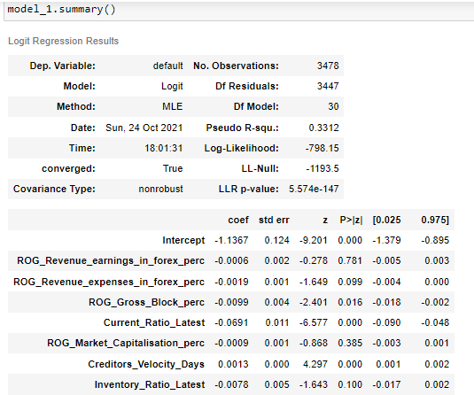

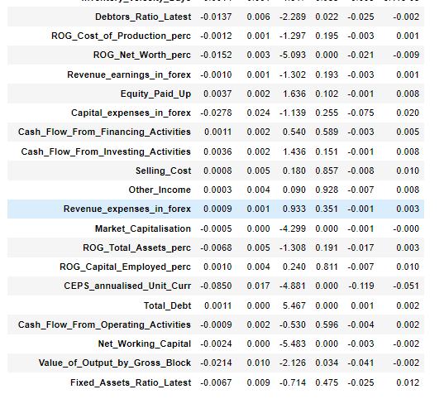
Adjusted pseudo R-square value is 0.30610154693161407 It is calculated as-
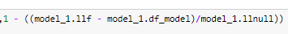
We can observe there are insignificant variables as adjusted pseudo R-square seems to be lower than Pseudo
R-square value and will not be useful in determining cases of target variable.
Let’s try & remove variables whose p value is greater than 0.05 & rebuild our model again

Model 2
Equation- f2 = 'default ~ ROG_Gross_Block_perc + Current_Ratio_Latest + Creditors_Velocity_Days + Debtors_Velocity_Days + Interest_Cover_Ratio_Latest + Debtors_Ratio_Latest + ROG_Net_Worth_perc + Market_Capitalisation + CEPS_annualised_Unit_Curr + Total_Debt + Net_Working_Capital + Value_of_Output_by_Gross_Block'
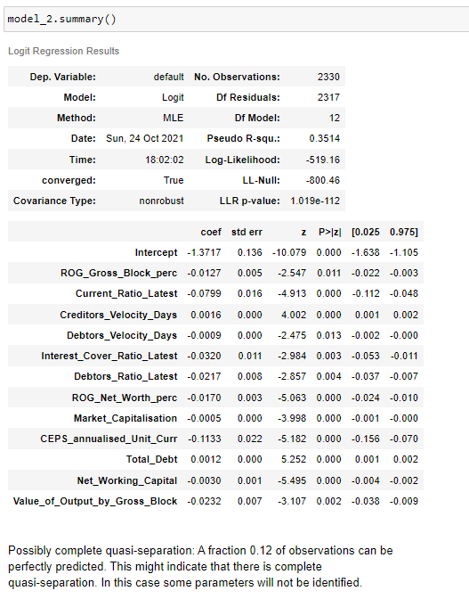
We can see that all variables are significant & may be useful to discriminate cases of default. Let us also check the multi collinearity of the model using Variance Inflation Factor (VIF) for the predictor variables
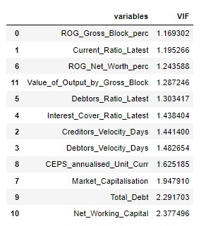
We can observe that multi-collinearity still exists but VIF are not very high so we won’t drop them. Adjusted pseudo R-square value is 0.33643
This shows lesser insignificant variables as adjusted pseudo R-square is close to Pseudo R-square value. Now, we can use this model for Prediction.
We will choose the optimal cut-off and show prediction in the next step.

  - Validate the Model on Test Dataset and state the performance matrices. Also state interpretation from the model

Prediction on the Data
Distribution plot of the logit function values
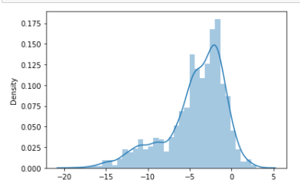
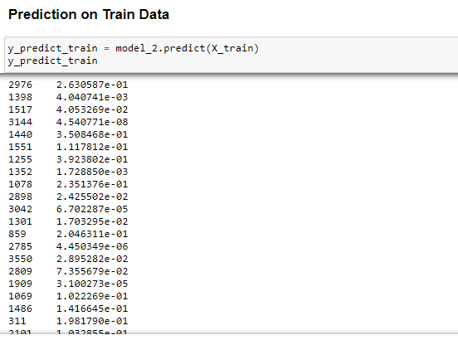

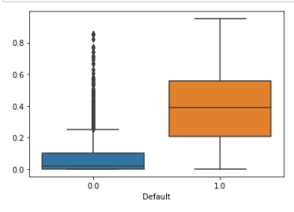

From the above boxplot, we need to decide on one such value of a cut-off which will give us the most reasonable descriptive power of the model. Let us take a cut-off of 0.15 and check.
Checking the accuracy using Confusion Matrix
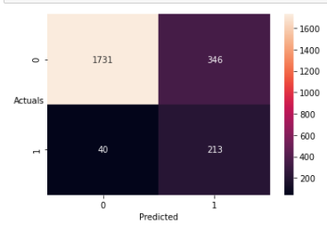
Now, using Classification Report
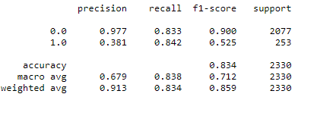
From the above observations, accuracy of the model i.e. %overall correct predictions is 83%. Sensitivity of the model is 84% i.e. 84% of those defaulted were correctly identified as defaulters by the model.

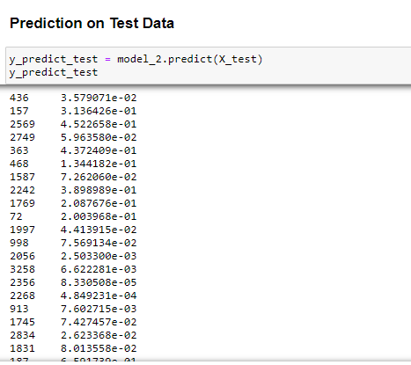
Checking the accuracy using Confusion Matrix
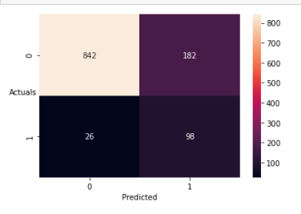
Now, using Classification Report
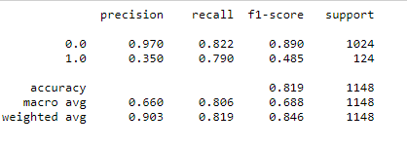
From the above observations, accuracy of the model is 81%. Sensitivity of the model is 79%. Accuracy, for both the Train data and Test data is good, so 0.15 can be seen as a good cut-off value.
Now, let us take a cut-off of 0.17 and check if our predictions have improved or not. Checking the accuracy using confusion matrix for training set
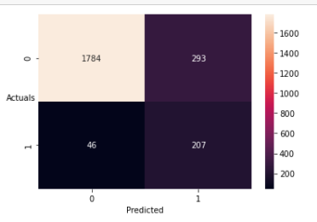
Now, using Classification Report
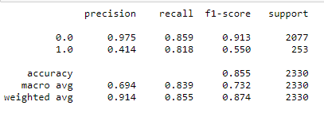
Accuracy has been increased from 83% to 85%, but sensitivity of the model has dropped slightly from 84% to 82%.
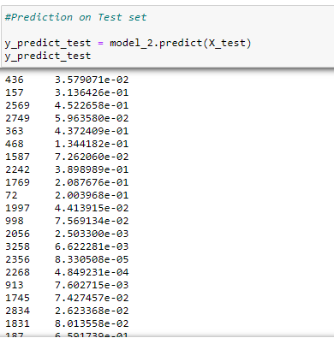

Checking the accuracy using confusion matrix for Test set
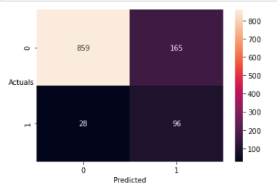
Now, using Classification Report on test set
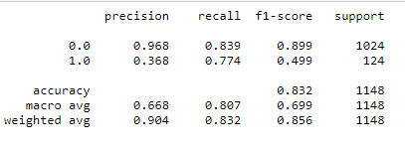

Accuracy of the model is 83% & sensitivity of the model stands at 77%
Inference-
• We may choose cut-off of 0.17 as it gave slightly lower model sensitivity from that of at 0.15 but the overall accuracy of the model is slightly more in test dataset.
• From the above analysis we see that approx. 11% of companies listed above are defaulters and are model is able to predict these with 83% of accuracy.
• The factors that affect whether the company will default or not are
- ROG_Gross_Block_perc
- CEPS_annualised_Unit_Curr
- Total_Debt
- Net_Working_Capital
- Value_of_Output_by_Gross_Block
- Current_Ratio_Latest
- Creditors_Velocity_Days
- Debtors_Velocity_Days
- Interest_Cover_Ratio_Latest
- Debtors_Ratio_Latest
- ROG_Net_Worth_perc
- Market_Capitalisation

The End

FRA MILESTONE 2
1.8 Build a Random Forest Model on Train Dataset. Also showcase your model building approach.
We have divide the data in the ratio 67:33 for random state = 42.
Random Forest Model Building-
We have used Grid SearchCV for hypertunning the parameters so that we can get the best parameters out of
the given.
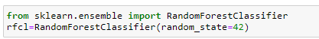
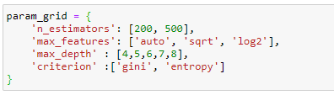
Best Parameters-
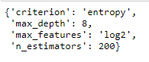
Now, we will use these above parameters to fit the model.

  - Validate the Random Forest Model on test Dataset and state the performance matrices. Also state interpretation from the model

Accuracy Score on Train data - 0.9909871244635193
Accuracy Score on Test data - 0.9773519163763066

Confusion Matrix
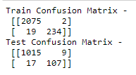
Classification Report
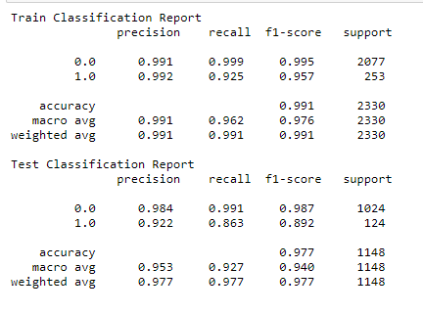
ROC Curve & AUC score-

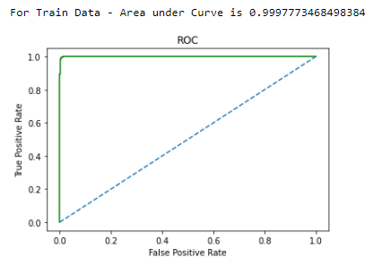

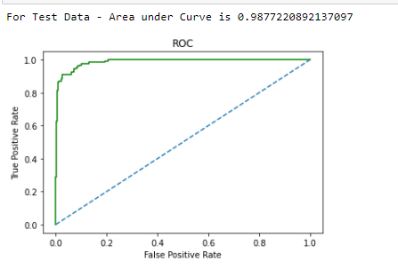
From the above observation we can say that Random Forest performed extremely well on the test data. There may be a case of overfitting but we can use boosting to further clarify the results

  - Build a LDA Model on Train Dataset. Also showcase your model building approach
Building LDA Model
Linear Discriminant Analysis or LDA is a dimensionality reduction technique. It is used as a pre-processing step in Machine Learning and applications of pattern classification. The goal of LDA is to project the features in higher dimensional space onto a lower-dimensional space in order to avoid the curse of dimensionality and also reduce resources and dimensional costs.
Again we have taken the same data split in 67:33 ratio and random state =42.
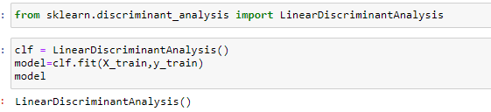

  - Validate the LDA Model on test Dataset and state the performance matrices. Also state interpretation from the model

Accuracy Score on Train data - 0.915
Accuracy Score on Test data - 0.909

Confusion Matrix
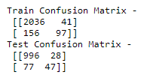
Classification Report
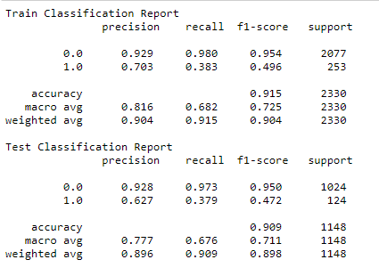

ROC Curve & AUC score-
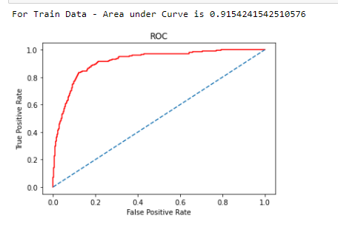

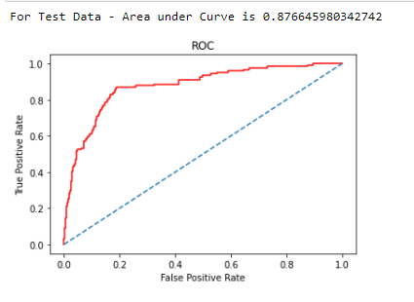
From the above observation we can say that LDA performed extremely well on the test data.

  - Compare the performances of Logistics, Radom Forest and LDA models
 | Logistic | Random Forest | LDA
Accuracy | 0.83 | 0.98 | 0.91

Confusion Matrix for Test data.
Logistic | Random Forest | LDA
[862 , 162]  [32 , 92 ] | [1020 , 4 ]  [16 , 108] | [999 , 25 ]  [78 , 46 ]

Classification Report for Test Data
For Logistic Regression-
For Random Forest –
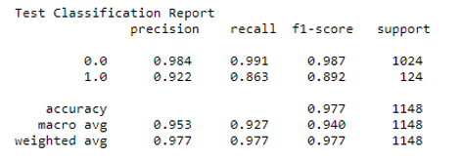
For LDA-
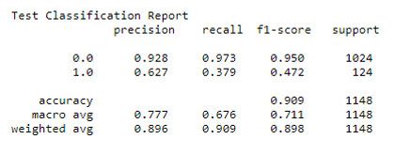

ROC Curve for Test Data-

For Random Forest-

For LDA-
  - State Recommendations from the above models

From the above Performance Metrics we can observe that
• Out of all the three models Logistic Regression and LDA performed the better
• Overfitting is found in Random Forest model that might improve using boosting techniques.
• Overall Logistic Regression performed the best out of the all three model with no under or overfitting issues.
• Also, dataset is not normally distributed the inclination is majorly on one side of the target variable.
• More data-points might help to get better understanding of the prediction data.
• Lot of variables which have no influence on the target variables these can be removed to improve the processing time.
• Inclusion of variables such previous loan defaults history and other factors might help in much better prediction.

Part 2-
Dataset - Market+Risk+Dataset.csv
Dataset after renaming columns
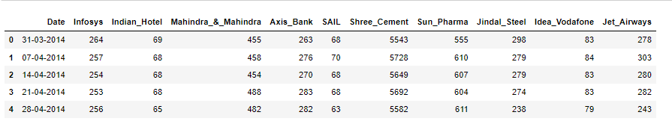
First, let us check the number of rows (observations) and the number of columns (variables)
The number of rows (observations) is 314
The number of columns (variables) is 11

Checking data types of all columns
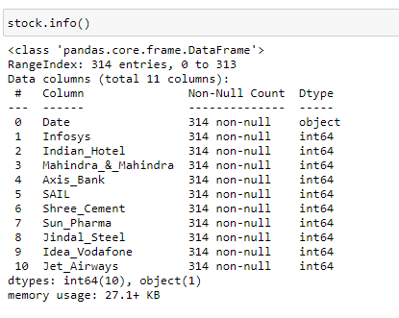
Descriptive statistics for the continuous variables.
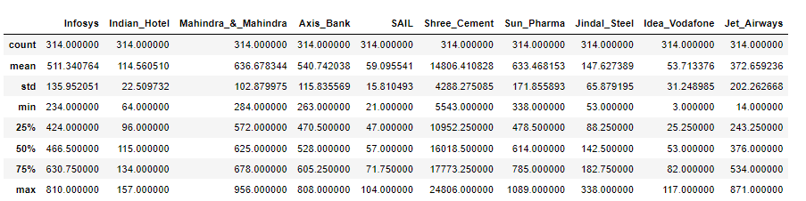
2.1 Draw Stock Price Graph (Stock Price vs Time) for any 2 given stocks with inference
For Infosys-
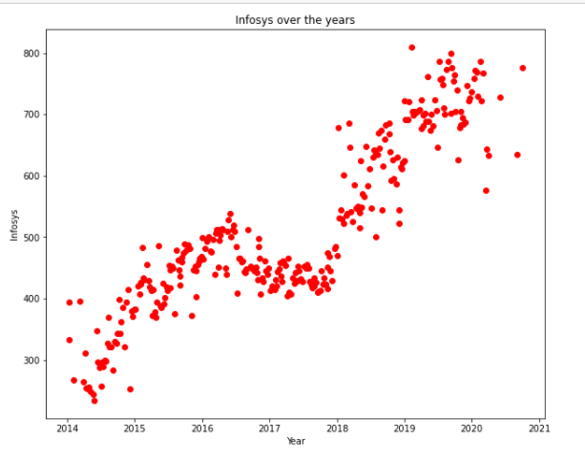
For Indian_Hotel
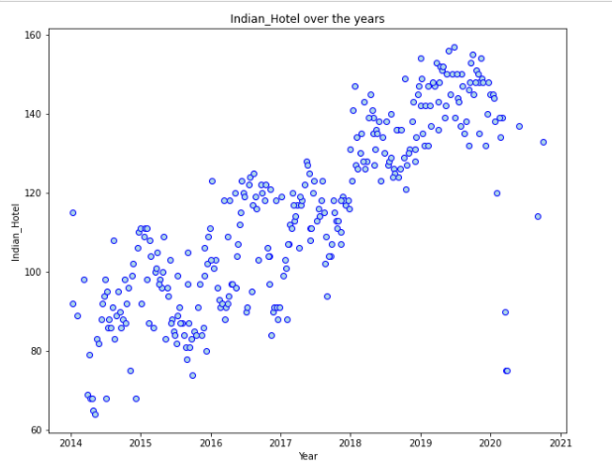

For SAIL-
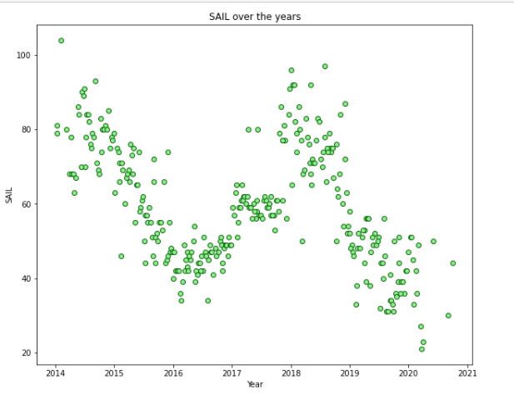
Inference –
* Stock prices over the years has increased for Infosys.
* Stock prices over the years has increased for Indian_Hotel.
* Stock prices over the years for SAIL is following a trend of upward downward ultimately going down.
* Among all three above Infosys has the maximum change in the stock prices over the years.

2.2 Calculate Returns for all stocks with inference

Steps for calculating returns from prices:
• Take logarithms
• Take differences

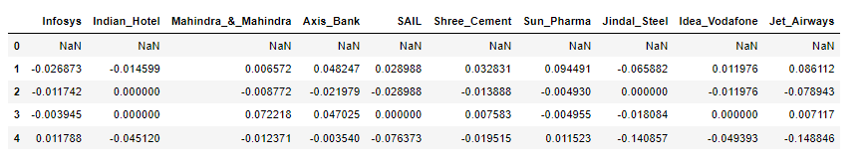

2.3 Calculate Stock Means and Standard Deviation for all stocks with inference

We now look at Means & Standard Deviations of these returns
Stock Means: Average returns that the stock is making on a week to week basis
Stock Standard Deviation: It is a measure of volatility meaning the more a stock's returns vary from the stock's average return, the more volatile the stock

Means-

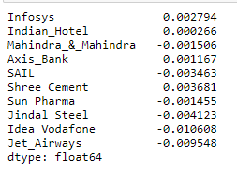

Standard Deviation-

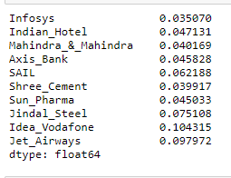

Now, below is the table consisting of Average (Stock means) & Volatility (Stock Standard Deviation).

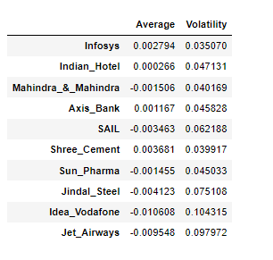
Inference –
• Shree_Cement has the max mean and Idea_Vodafone has the minimum mean.
• Infosys has the least standard deviation and Idea_Vodafone has the maximum standard deviation.
• From the above Infosys and Shree_Cement have the best returns in the market, as they have the highest mean and lowest standard deviation.

2.4 Draw a plot of Stock Means vs Standard Deviation and state your inference

Let us plot & see what they say about stock prices

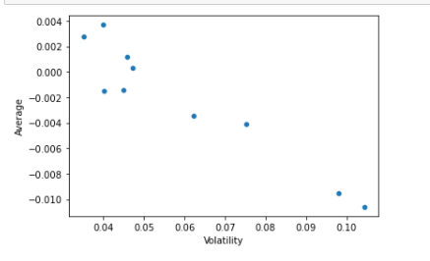
2.5 Conclusion and Recommendations

Stock with a lower mean & higher standard deviation do not play a role in a portfolio that has competing stock with more returns & less risk. Thus for the data we have here, we are only left few stocks:

• Ones with higher return for a comparative or lower risk are considered better
• Here, Shree_Cement and Infosys have the best returns for the stock prices.
• Also the trend is linearly increasing over the years for Infosys and Shree_Cement.
• It will be wise to invest in these companies for long term investments which are showing promising returns

THE END

